3. Getting Started 3-1
COMMON BUTTONS AND SCREEN ELEMENTS 3-1
COMMON BUTTONS 3-1
COMMON MENU BUTTONS PULL-DOWN MENUS 3-1
Pull-Down Menus 3-2
NAVIGATION BARS 3-2
SCROLL BARS 3-2
TREE view MENUS 3-3

FILE IS C:\WORK\SCMgr\Documents\new manual\SCMgr-sec3.doc
TEMPLATE IS MANUAL.DOT

Heading needed to allow for header number in page and figure numbering. (edit as needed)

This is an information page. Do not include it in the finished manual.

This is an information page. Do not include it in the finished manual.

Getting Started

COMMON BUTTONS AND SCREEN ELEMENTS
The following common buttons and screen elements are used in Supply Chain Manager:

COMMON BUTTONS

Button | Usage
 | Creates a new record.
 | Edits the current record.
 | Deletes the current record (if the record can be deleted).
 | Prints the current record or report.
 | Displays the previous record in the list.
 | Displays the next record in the list.
 | Returns to the previous screen.

COMMON MENU BUTTONS PULL-DOWN MENUS

Button | Usage
 | Exits Supply Chain Manager.
 | Returns to the main menu from any submenu.
 | Returns to a submenu.

Pull-Down Menus
Pull-down menus, similar to Figure 3-1, let you choose from a list. To use a pull-down menu, click on the arrow next to the menu to display its list, then click on the item you wish to select. The sample at right shows that Central was chosen from the Distribution Role pull-down menu.

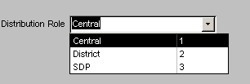
Figure 3-1 – Pull-down menu (pull-down-1.bmp)You can also select an item from a pull-down menu by clicking on the associated field and typing the first letter of the item you wish to select.

NAVIGATION BARS
Navigation bars let you move from page to page in a multi-page report. Figure 3-2 shows that the current page of a SCMgr report is 10.

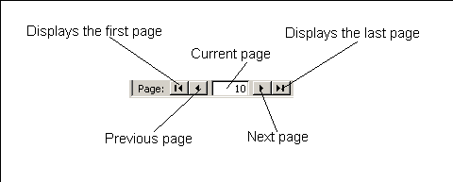
- Figure 3-2 – Navigation bar (nav-new.bmp)Click on an arrow button at either end of the navigation bar to display a record as shown below.

SCROLL BARS
Vertical and horizontal scroll bars on some Supply Chain Manager screens let you view more data than your screen can display at one time.

- Click on an arrow button to move in the indicated direction.

 | Left |  | Down
 | Righ |  | Up

Figure 3-3 is an example of horizontal and vertical scroll bars.

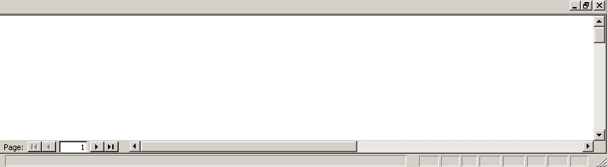
Figure 3-3 -- Vertical and horizontal scroll bars
 | To quickly scroll through a screen, click on the square button at the right end or bottom end of the horizontal or vertical scroll bar and move it up/down or left/right while holding down the left mouse button.

TREE view MENUS
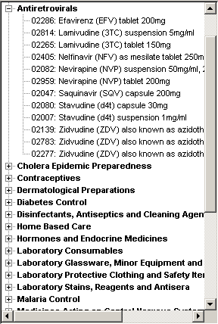
Figure 3-4 – Tree Menu (tree-view-1.bmp)Tree view menus represent a hierarchical data structure, such as categories and subcategories of products on the Product Tracking form, or nested reporting groups on the Product Background form.

Tree menus (Figure 3-4) allow you to view all the categories, subcategories and products in the distribution system.

To the left of each category and subcategory is a plus or minus sign.

- To view the subcategories and products in a category, click the plus sign.

- To collapse the list of subcategories and products, click the minus sign.

